STEP-1
- Open the Visual Studio 2026.
- Click on the File New Project/Solution.
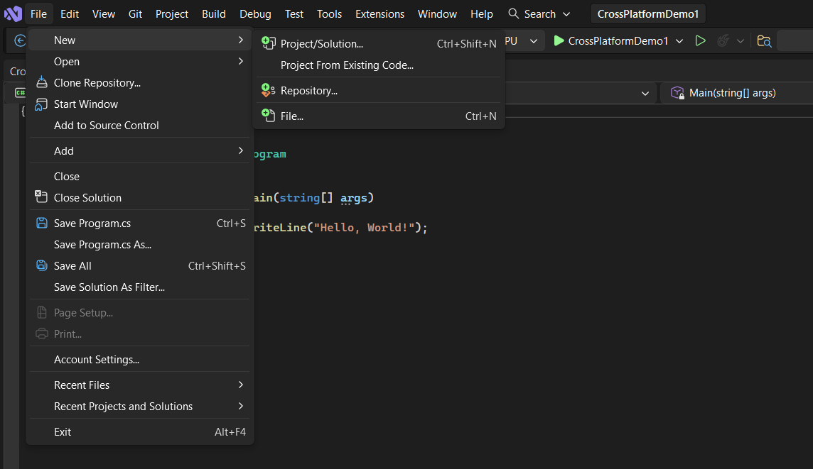
STEP – 2
- Select the C# language and then Select the Console App.
- Click on the Console App and right after that Click on the Next button.
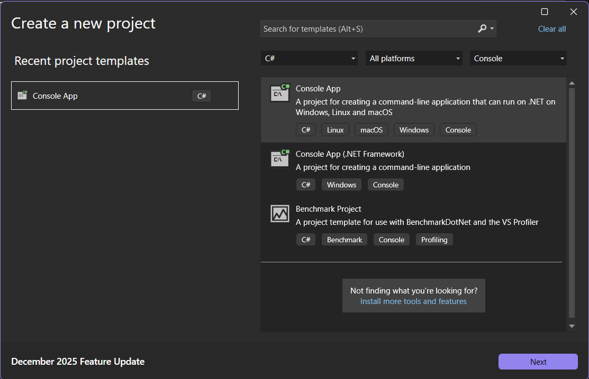
STEP – 3
- After Clicking on the Next button, a Dialog box appears.
- Change the Name of the project in the Project name section.
- Click on the Next Button.

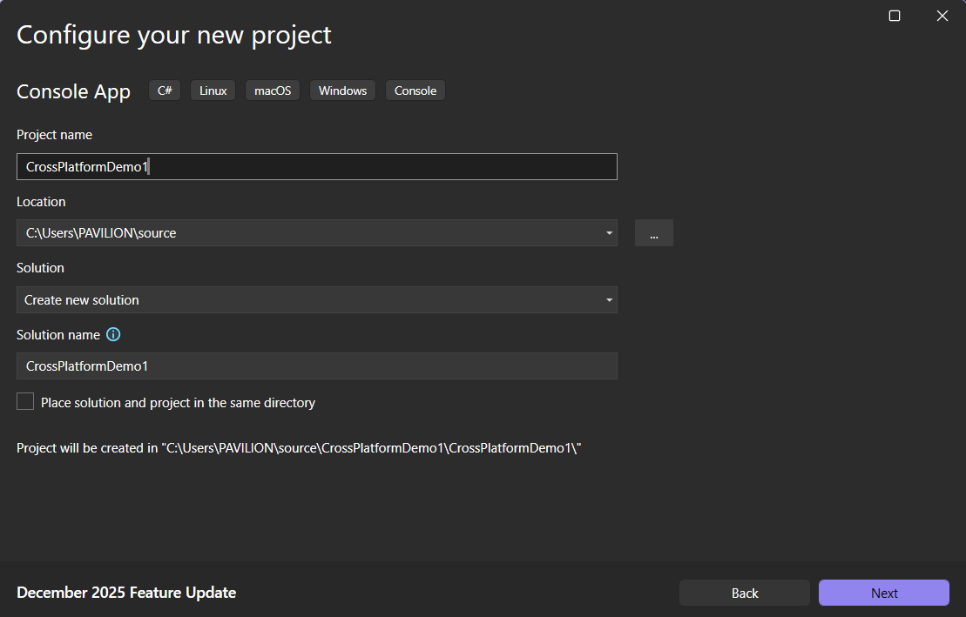

STEP- 4
- Select the .NET Framework using the drop down on the .NET Framework Section.
- It is recommended to use the .NET 8.0 LTS Framework.
- Make sure to check the checkbox stating Do not use Top Level Statements.
- Click on the Create Button.

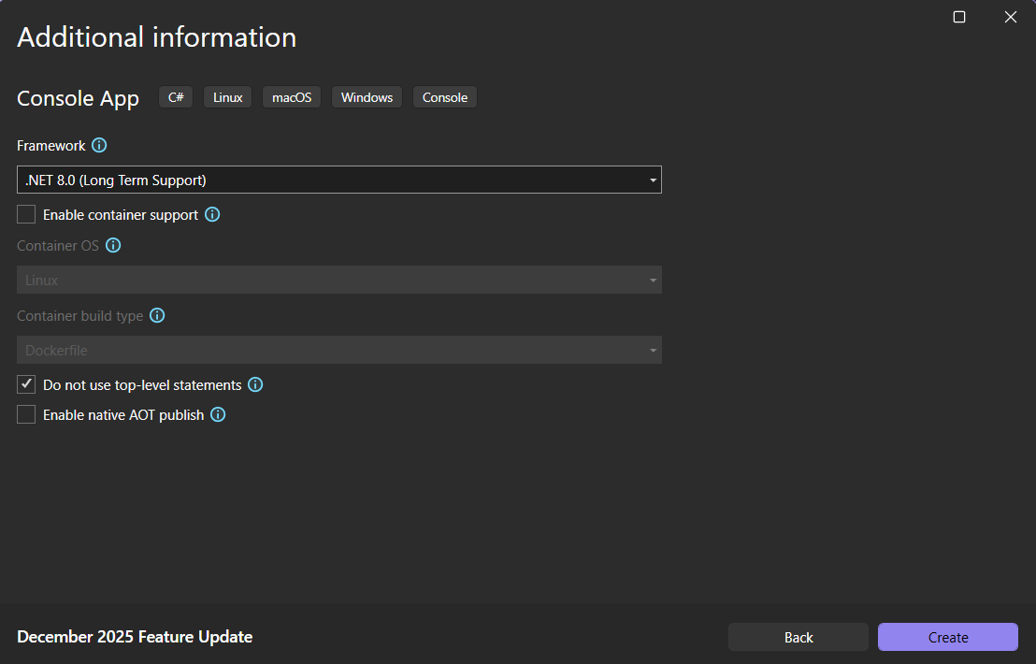

STEP – 5
- On the Solution Explorer Window. Right Click on CrossPlatformDemo1.
- A Dialog Box will appear, click on the Publish option in that.

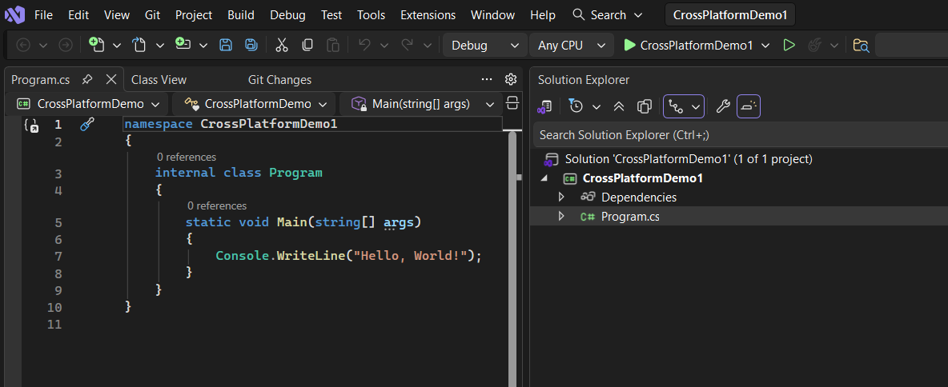
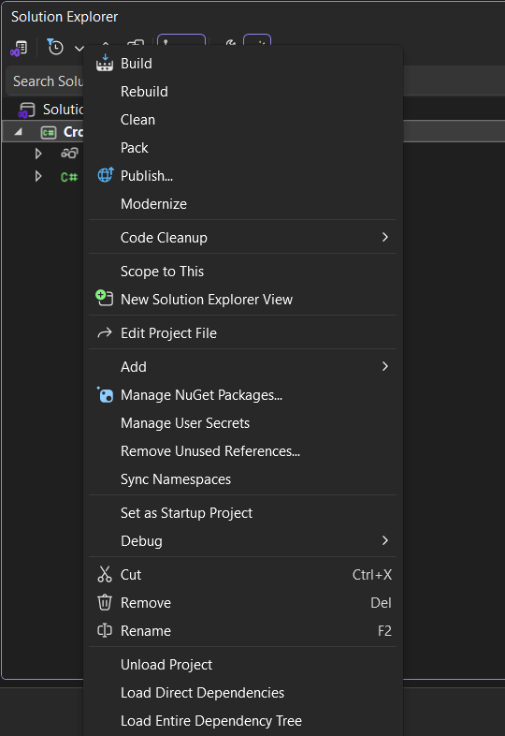

STEP – 6
- After Clicking on the Publish, a Publish Window will appear.
- Select the Folder option and Click on Next.
- Repeat the same step.
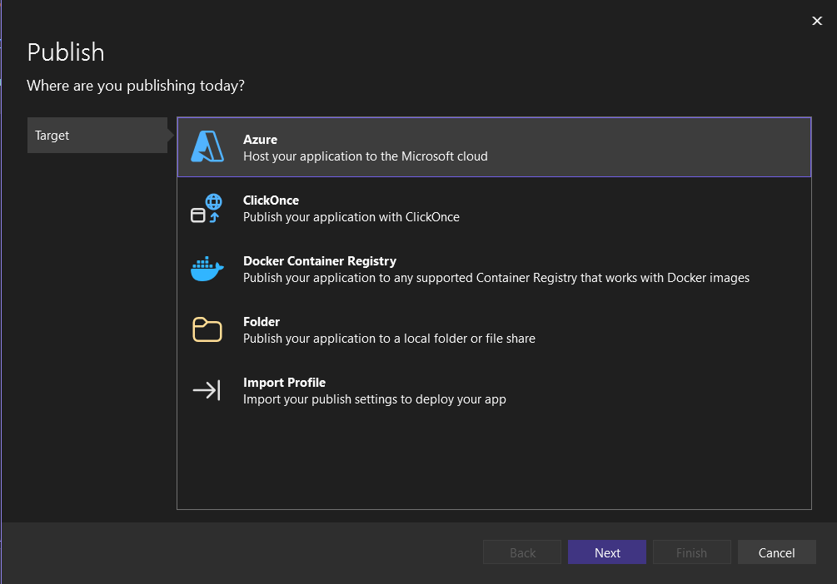
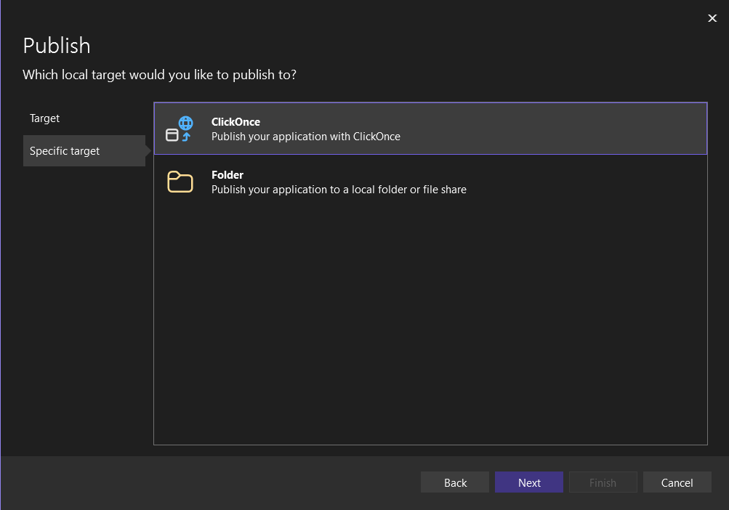

STEP-7
- A Publish Window with Location information will appear.
- In the Folder Location Section, A Location Path is given which tells about the location of the Folder in the System.
- Click on Finish and then Close.
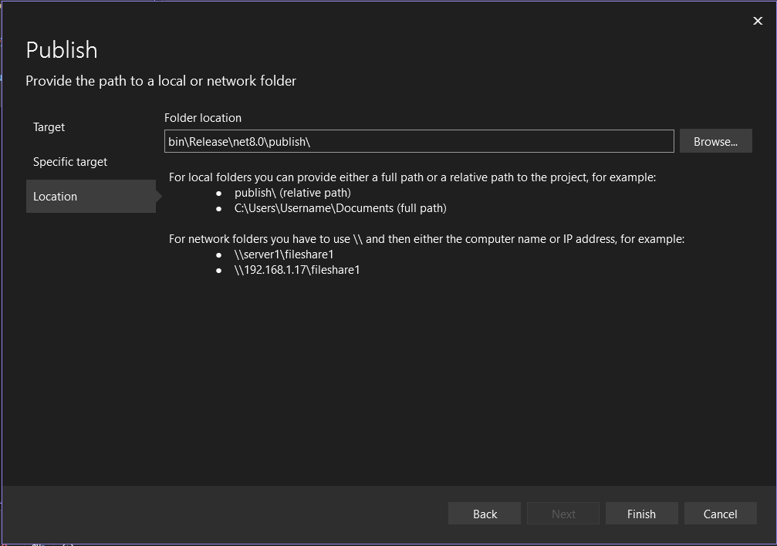
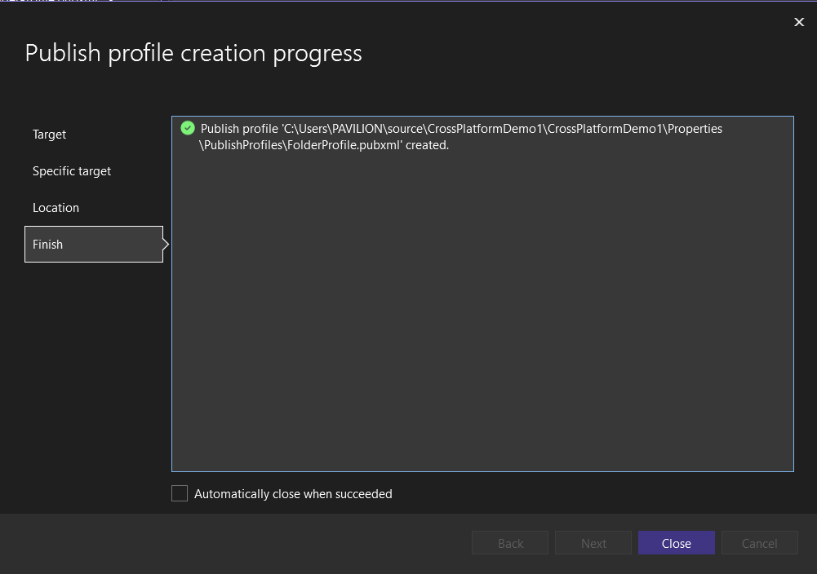

STEP – 8
- A Profile Window is appeared.
- Click on More action on top of Ready to Publish.
- Click on Edit Option.

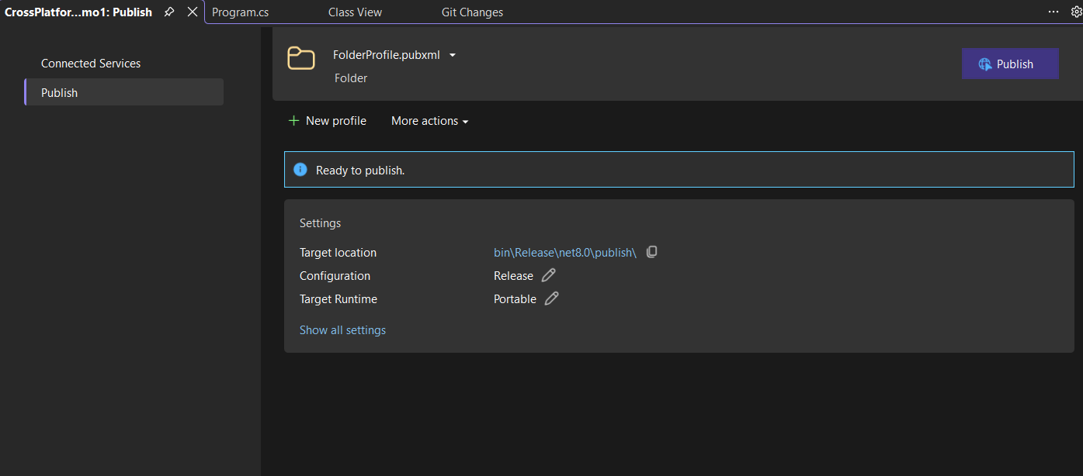
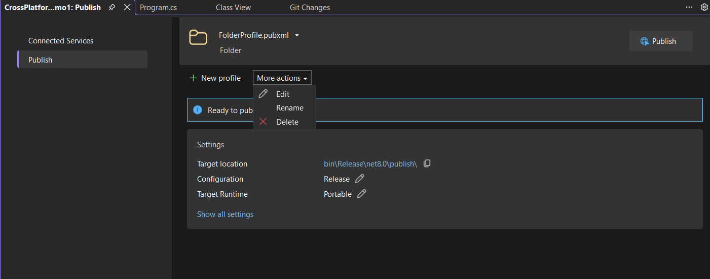

STEP – 9
- A window named Profile Settings is opened.
- Click on the dropdown of Deployment Mode.
- There will be 2 Options: Framework Dependent and Self Contained.
- Use Framework Depended when the Other System already has the CLR.
- Use Self Contained When the other system does not have the CLR.

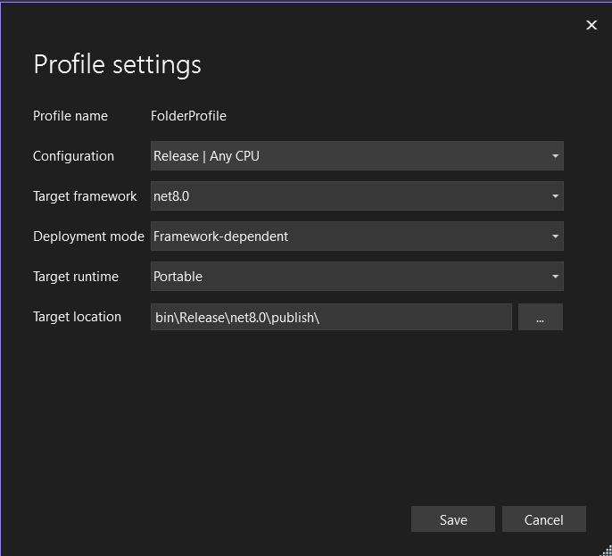
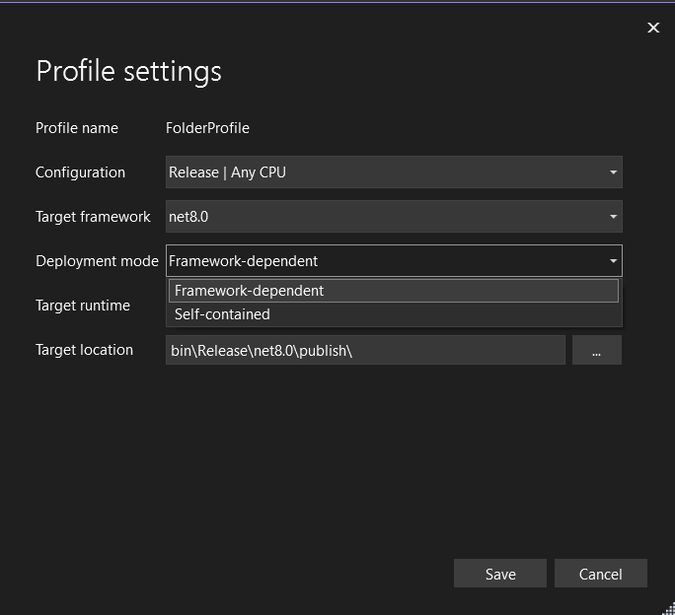

STEP -10
- After Selecting the Deployment Option. Click the dropdown on the Target Runtime.
- Select the required Operating System. For Example, Linux-x64
- Click on the Save button.
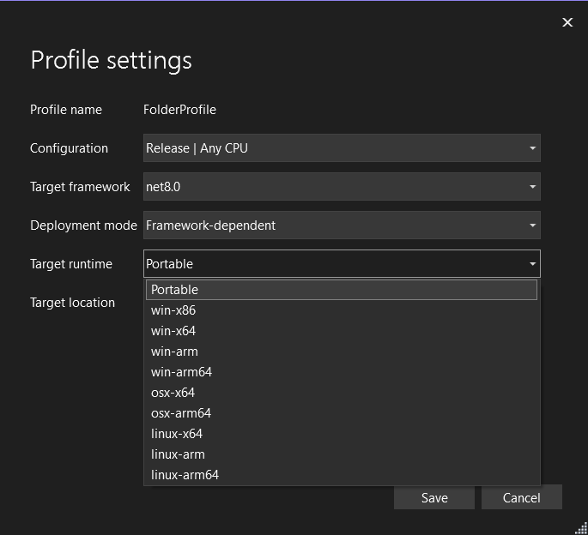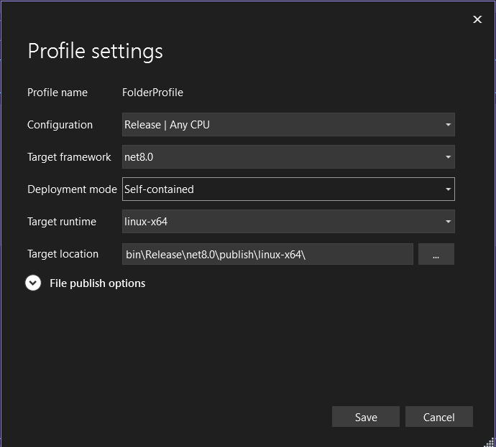

STEP – 11
- After Saving the Requirements, A ready to Publish Window is Appeared.
- Click on the Publish Button on the top right.
- A successful status is displayed with a green tick ensuring that the project is successfully Published.

